7 Clanwilliam Terrace
Grand Canal Quay
Dublin 2
D02 CC64
Email: info@ipha.ie
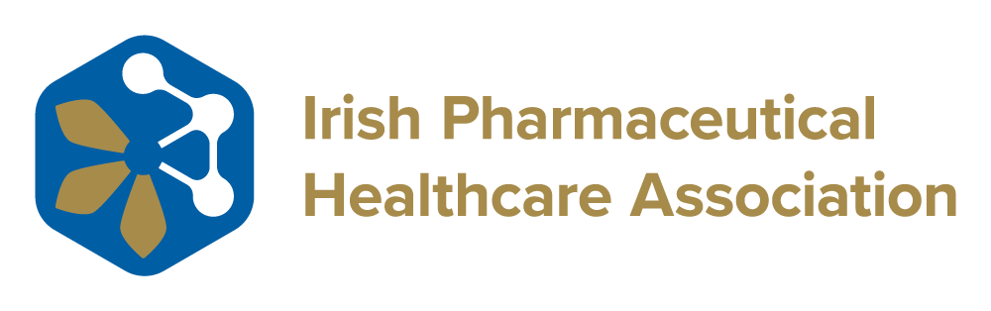

The HSE’s National Office has acquired a new data protection tool from EY Law and this is now active at clinical trial sites or through the national legal office. This tool has two uses, firstly it conducts a third country transfer legislation assessment and issues a report on the difference in the law in the transferring country compared to that of the EU law on Privacy and Data Protection. Secondly, that data can be used to complete a TIA in the system and this is available for uploading in PDF.
Racheal Batton, National Lead for Legal Support and Data Protection within the R&D Department of the HSE, has advised that ‘Where this is being conducted the National Research Offices does not require the additional HSE TIA form to be completed as part of its business data protection compliances requirements’. It is understood that from the end of October 2023, license holders will be provided with direct training on the tool.

